# VLF – Very Low Frequency

Very low frequency (3 kHz – 30 kHz) radio waves propagate thousands of kilometres in the Earth-ionosphere Waveguide (EIWG) formed between the conducting Earth and the ionosphere. During daytime, the ionospheric D-region (at an altitude of 60 km – 90 km) acts as the upper boundary of the EIWG, whilst at night the D-region becomes much weaker, and the boundary moves to higher altitudes. Diurnal and seasonal changes in the ionosphere cause the reflection height of the EIWG to change in a predictable way, whereas space weather events produce seemingly random modifications of the ionosphere, which affect the characteristics of the EIWG and therefore also VLF propagation.



Figure 1. Atmospheric layers.

From a scientific perspective, though, the reflectivity of the D region at these frequencies make ELF/VLF a unique tool for remote sensing of the D region, which responds to a variety of inputs like solar activity, lightning energy, electron precipitation from the radiation belts, cosmic gamma rays, and earthquakes. Measurements of properties of the D region are extremely difficult, since those altitudes are too high for balloons, yet too low for satellites, so this is a useful ability.

The Space Physics Research Institute (SPRI) from the University of KwaZulu Natal (UKZN) historically conducted various Very Low Frequency (VLF) projects at the Base. However, management of the projects was handed over to SANSA. Since then, several other international research institutions, such as the University of Washington, Stanford University, etc., have collaborated with SANSA to expand the scope of VLF projects and produce world class research.

The Space Weather engineer is responsible for the following VLF Systems:

* World Wide Lightening Location Network (WWLLN).
* UltraMSK
* Digital Very Low Frequency Recording and Analysis System (DVRAS)
* AWD - PLASMON.
* VLF Doppler

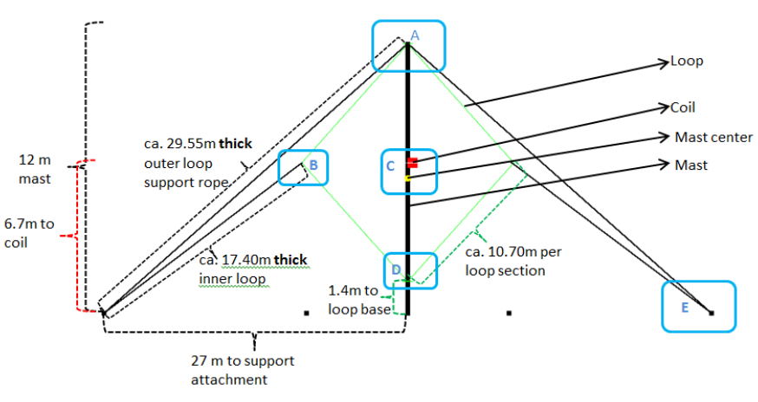

Figure . VLF antenna construction.